LOAN ANALYSIS PROJECT OVERVIEW
1.Created Database in SQL Server with name “Loan” and import the (Loan_default.csv) flat file to the database.

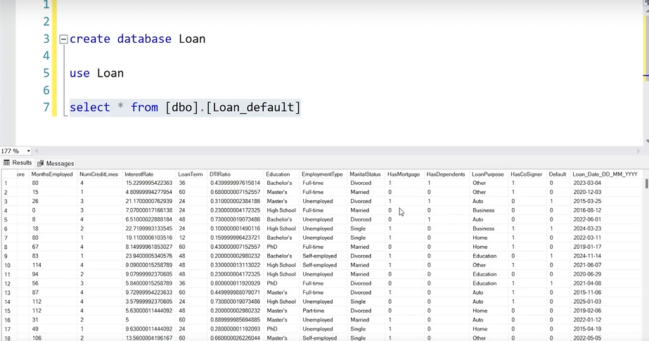
2. Created a Dataflow (Gen1) in Microsoft Fabric, authenticating with SQL Server to ingest and transform data into the Fabric Lakehouse on a scheduled refresh basis.
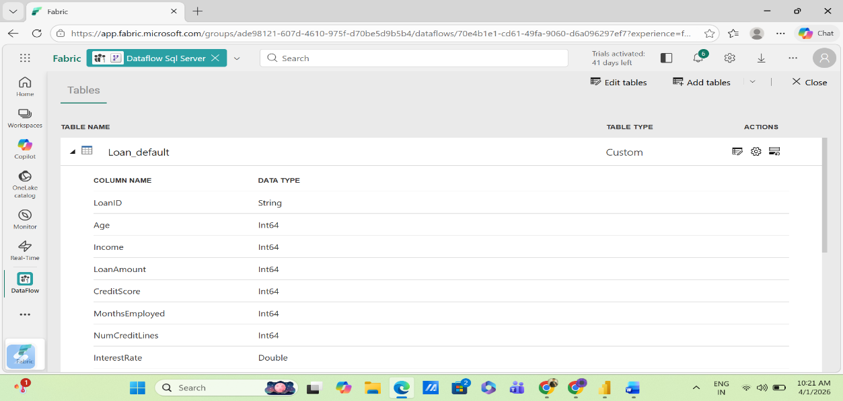
3. Imported data into Power BI Desktop from dataflow
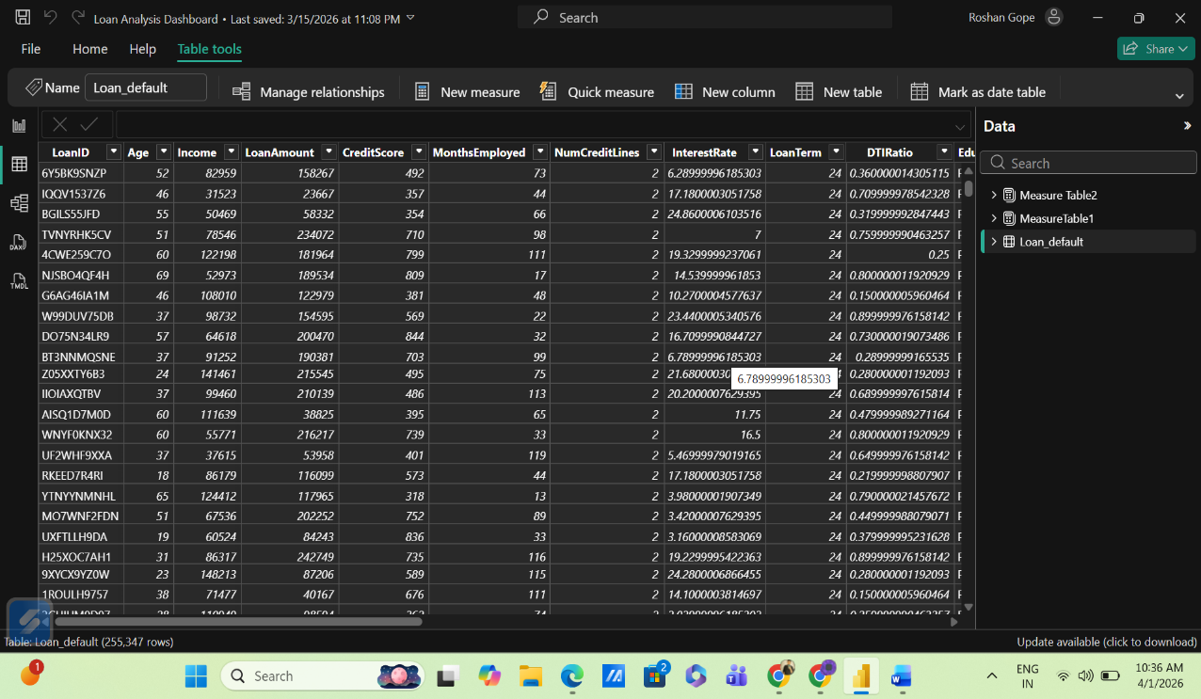
Loan Default Dataset Description
The Loan Default Dataset contains information about borrowers who have applied for loans, along with details about their financial status, loan characteristics, and repayment behavior.
Column Name | Definition
LoanID | A unique identifier for each loan in the dataset.
Age | The borrower's age at the time the loan was issued.
Income | The borrower's annual income
LoanAmount | The total amount of the loan that the borrower is requesting or has been approved for.
CreditScore | A numerical representation of the borrower's creditworthiness, typically ranging from 300 to 850. A higher credit score indicates the borrower is more likely to repay the debt.
MonthsEmployed | The number of months the borrower has been employed at their current job or with their current employer.
NumCreditLines | The total number of active credit lines (e.g., credit cards, loans) the borrower has at the time of applying for the loan.
InterestRate | The annual percentage rate (APR) charged for borrowing the loan amount, usually expressed as a percentage.
LoanTerm | The length of time (in months) over which the loan is to be repaid.
DTIRatio | The Debt-to-Income ratio, which measures the borrower’debt payments relative to their income. A higher ratio can indicate greater financial stress.
Education | The highest level of education the borrower has completed (e.g., High School, Bachelor’s, Master’s, etc.).
EmploymentType | The type of employment the borrower is engaged in (e.g., Full-Time, Part-Time, Self-Employed, etc.).
MaritalStatus | The marital status of the borrower (e.g., Single, Married, Divorced, etc.).
HasMortgage | An indicator (e.g., Yes/No) that shows whether the borrower has an existing mortgage on a property.
HasDependents | An indicator (e.g., Yes/No) that shows whether the borrower has dependents (children, other family members) to support.
LoanPurpose | The primary reason for taking out the loan (e.g., Home Purchase, Debt Consolidation, Education, etc.).
HasCoSigner | An indicator (e.g., Yes/No) that shows whether the borrower has a co-signer for the loan (someone who agrees to take responsibility if the borrower defaults).
Default | An indicator (e.g., Yes/No) that shows whether the borrower defaulted on the loan or failed to make timely payments.
Loan Date (DD/MM/YYYY) | The date the loan was issued or originated.

4. Utilized Power Query Editor to perform column profiling, ensuring data quality by handling null values and optimizing data types for downstream analysis.
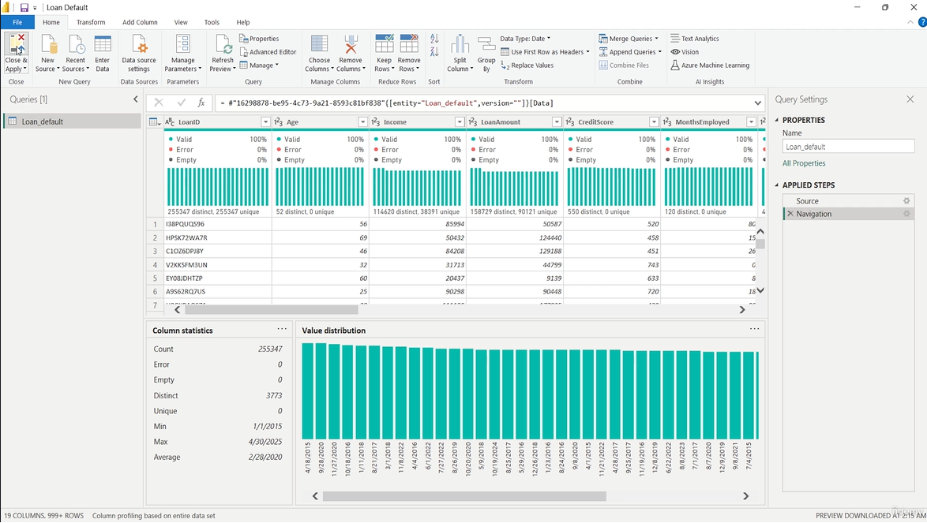
5. Created a DAX Measure to calculate Loan Amount By Purpose
6. Created a DAX Measure to calculate Loan Amount By Different Age groups
7. Created a DAX Measure to calculate the percentage of loan defaults for different employment categories.
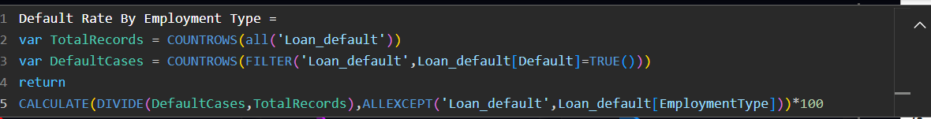
8. Created DAX measure to calculate the annual default percentage. It determines what portion of loans issued in a specific year ended in default, effectively allowing you to track risk trends over time.
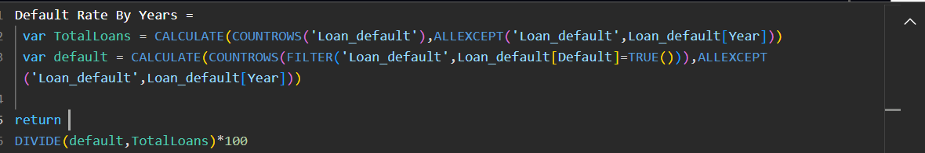
9. Created measure to calculate the total sum of loan amounts, but it adds a specific safety layer by explicitly excluding any rows where the LoanAmount is missing or blank.
10. This DAX measure calculates the average loan value specifically for borrowers who fall into the "High" credit score category.
11. This DAX measure calculates the total volume of loans distributed across different education levels, ensuring that only valid records with a unique LoanID are counted.
12. This DAX measure calculates the median loan amount across the dataset.
13. This DAX measure calculates the total capital lent specifically to the "Middle Age Adults" demographic.
14. This DAX measure calculates the total financial exposure specifically for the "Adults" age group, while locking the calculation to focus on age and credit-related data.
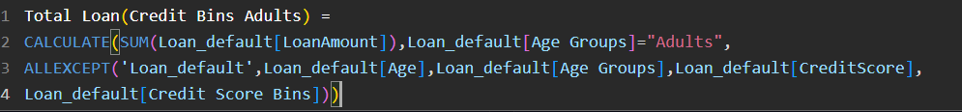
15. This DAX measure calculates the Year-over-Year (YoY) percentage change in the number of defaulted loans.
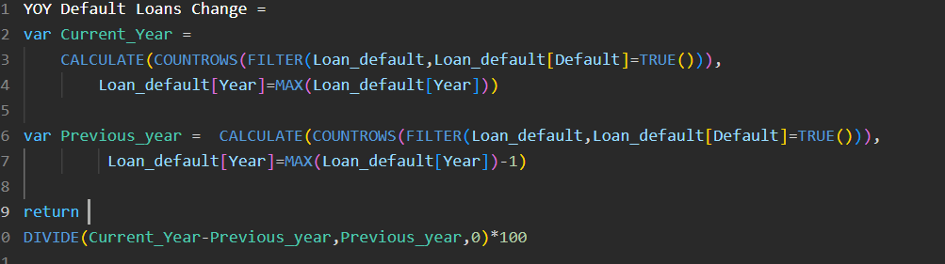
16. This DAX measure calculates the Year-over-Year (YoY) percentage growth in loan volume, helping you track how the total capital disbursed has changed compared to the previous year.
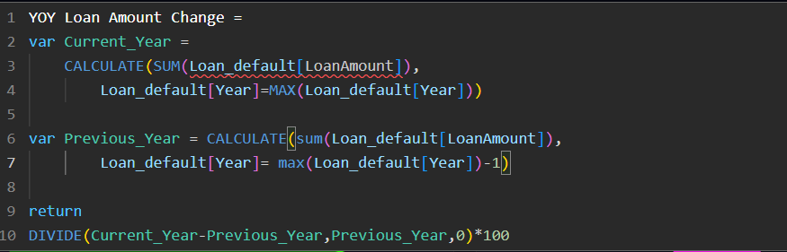
17. This DAX measure calculates the Year-to-Date (YTD) cumulative total of loan amounts, specifically designed to track the running sum of lending volume from the start of the current year up to the latest date available.
19. Created the First Dashboard to visualize the overview of the Laon_Default
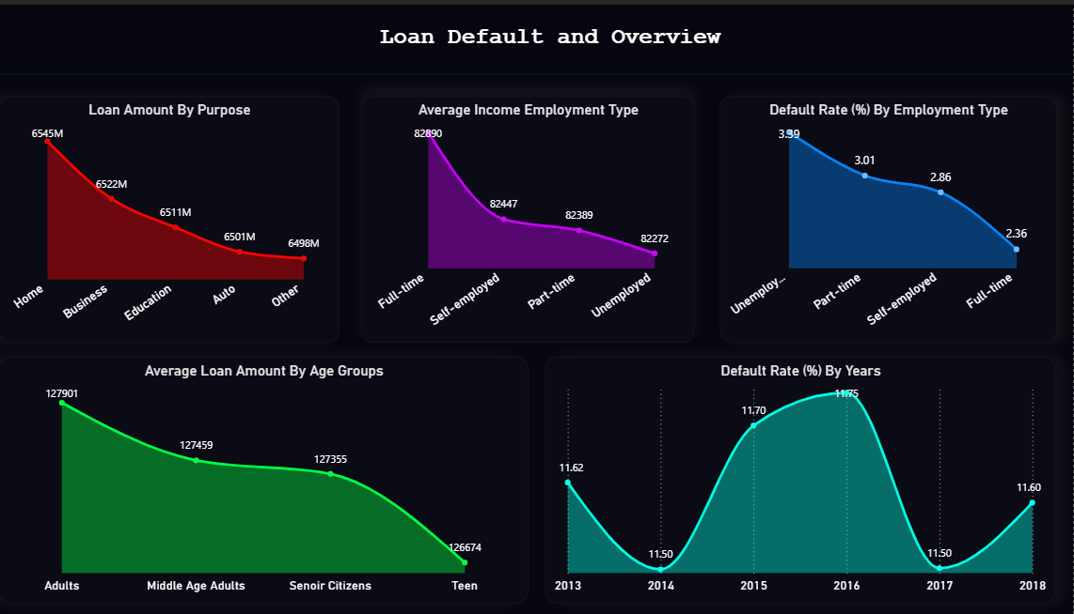
2. Created the Second Dashboard to visualize the Applicant Demographic and Financial Profile
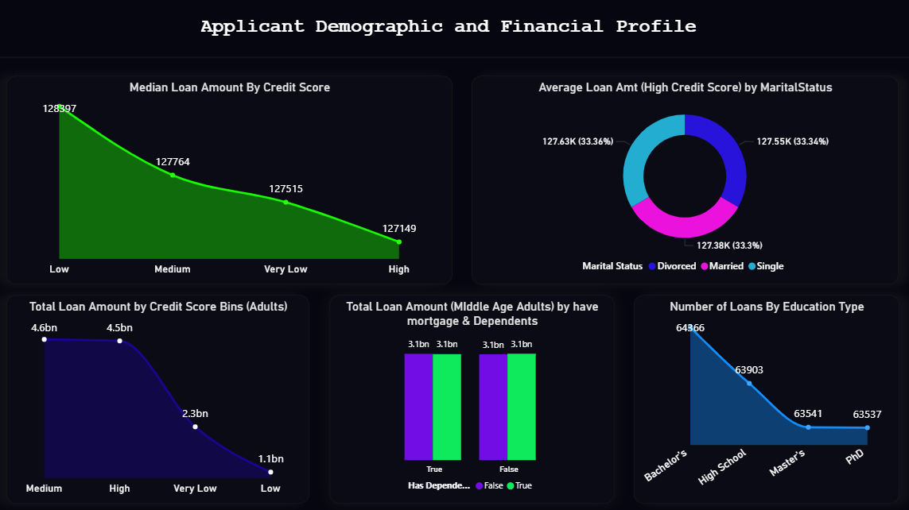
3. Created the Third Dashboard to visualize the Financial Risk Metrics
